Learning Java Programming Language with Open Source Products and Technologies
By Blasius Lofi Dewanto

Abstract
This article outlines how Open Source Software can support the educational process in general and teaching and learning the Java programming language in particular. The relationship between the NetBeans Java IDE (Integrated Development Environment), FSL (Freestyle Learning) and OpenUSS (Open University Support System) will be shown as an integrated process of teaching and learning in the university environment.

Introduction
At most universities, Java has become the main programming language used for teaching programming language concepts [1]. Java is also regularly used in student coursework, practical examples, and assignments. This generally has little or no impact on the cycle of teaching and learning programming language concepts and the programming language itself in the university environment. This cycle still follows the traditional pattern:

- The teacher prepares lectures, exercises and examination materials.
- The teacher gives some introductory lectures on the subject (in this case Java as a programming language).
- The students study the subject by reading assigned books and educational materials. The students also practice the programming activities by writing their own Java programs.
- The students complete exercises and homework in preparation for the examination.
- The students can optionally participate in discussion groups to go over any questions arising from their studies.
- The students take the examination.

These days, almost all universities support the concept of teaching and learning with computer supported systems. Computer Assisted Learning and Computer Assisted Teaching (CAL+CAT) has already been fully developed and implemented at the Lehrstuhl fuer Wirtschaftsinformatik und Controlling an der Universitaet Muenster (Department of Information Systems, University of Muenster) in Germany. For the German spoken readers please refer to [2]. This model allows you to adjust the implementation of the teaching and learning process to your organizational needs. You can therefore use the CAL+CAT model to support instruction in any field, including the Java programming language.

Before we look at the model itself, let's take a look at the various types of software that are used in the CAL+CAT model. They are as follows:
- Learning Management System (LMS) is the main vehicle for managing the teaching and learning process. This software bundle is designed for management at the individual, classroom and institutional levels. Communication management software (synchronous and asynchronous communication) can also be integrated with LMS, either as part of the software package or as a stand-alone component that can be easily integrated into the LMS. The main characteristic of LMS is that the users - in this case teachers and students - need to be connected to the internet to use the software.
- Computer Based Training (CBT)/Course Authoring Package (CAP). CBT is offline software that supports the learning process locally at the student's computer. Although this type of software usually works online as well, most users prefer to use the software from a CD-ROM because of the large bandwidth required to process the CBTs' large videos and client/server interaction. CAP is normally used for developing content for CBT software.
- Java Development Tools (JDT) is the environment in which students get hands-on experience in programming with Java. JDT software is normally installed on the student's computer and is used offline. Text editors, compilers and debuggers fall under this heading.

Now that we've said something about CAL+CAT tools, we can take a look at how they are used in the education cycle. Fig. 1 gives a detailed view of how the process of teaching and learning Java can be supported by CAL+CAT software.

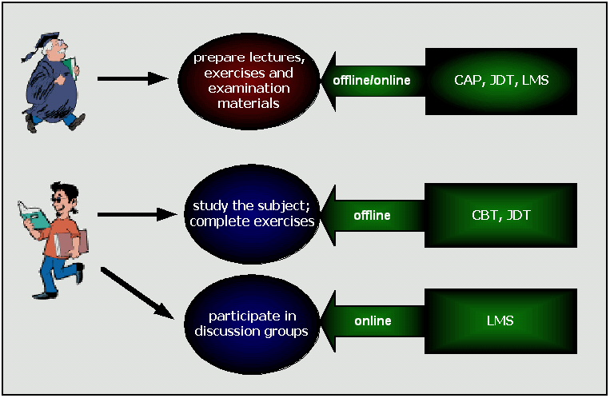
Fig. 1: Teaching and learning process supported by software applications

Commercial Vendor and Open Source Software Support
A wide range of commercial software developers produce applications that can be used in the educational process. Tab. 1 gives a short overview of such companies.

Vendor | Type
BlackBoard: http://www.blackboard.com | LMS
eCollege: http://www.ecollege.com | LMS
WebCT: http://www.webct.com | LMS
CampusPipeline: http://www.campuspipeline.com | LMS
TutorsEdge: http://www.tutorsedge.com | Virtual Classroom (synchronous communication)
Toolbook: http://home.click2learn.com/products/toolbook.html | CBT/CAP
Macromedia Flash, Freehand, Director, Authorware: http://www.macromedia.com/software | CBT/CAP
JBuilder: http://www.borland.com/jbuilder | JDT
VisualAge: http://www.ibm.com | JDT
Tab. 1: Commercial vendors

What about open source software? Do any open-source alternatives to the above-mentioned products exist? The answer is yes! Thanks to the immense amount of activity in open source software development over the last couple of years, open source versions now exist for most educational software applications. Tab. 2 shows some open source educational resources.

Open Source | Type | Programming language
ClassWeb Open Source Distribution: http://classweb.ucla.edu | LMS | PHP templates and Perl CGI scripts
The Manhattan Virtual Classroom: http://manhattan.sourceforge.net | LMS | CGI in C language
ShadowNetworkspace: http://sns.internetschools.org | LMS | CGI scripts C and Perl
Authenticated User Community (AUC): http://auc.sourceforge.net | LMS | CGI scripts C and Perl
OpenUSS: http://openuss.sourceforge.net | LMS | Java (J2EE)
Freestyle Learning: http://www.wi.uni-muenster.de/aw/freestyle-learning/english/eindex.htm  FSL is a fully developed product already in use at the University of Muenster. This project was recently declared an open source project. | CBT/CAP | Java (Swing)
jEdit: http://jedit.sourceforge.net | JDT | Java (Swing)
Jext: http://jext.sourceforge.net | JDT | Java (Swing)
NetBeans: http://www.netbeans.org | JDT | Java (Swing)
Tab. 2: Open source software

Presently, the only portal for open source software in the educational field is CampusSource (http://www.campussource.de in German or http://www.campussource.org in English). CampusSource is a German project that already has many projects under its umbrella (including OpenUSS). All CampusSource projects use GPL as their licence form. The main target of CampusSource is to bundle and integrate available open source software in the educational area.

These open source alternatives are all as effective if not better than their commercial counterparts, so there's no real reason not to use open source software in the educational area - especially in teaching and learning Java as a programming language. Open source software therefore presents a very valuable resource for educational institutions, which often don't have the financial resources to purchase commercial products.

Using NetBeans, FSL and OpenUSS in the Teaching and Learning Process
For additional information about each product please refer to the pdf documents at the end of this article [3].

Now that we've looked at the role of open source software in the teaching and learning process, let's focus in on how three specific Java open source products can be used in this area. This section examines the capabilities of NetBeans, FSL and OpenUSS from two perspectives. The first perspective is that of the user, which demonstrates how the power of these three products come together to support teaching and learning Java. The second perspective is that of the developer. With the power of Java, independent developers can add new functionality to these products. Java's ”learn once use everywhere” paradigm makes it easier for Java developers to further develop open source projects like NetBeans, FSL and OpenUSS for the widest possible market.

The integration of NetBeans, FSL and OpenUSS greatly enhances the educational cycle for Java as a programming language. A typical CAT+CAL scenario would be as follows (see Fig. 2):

- The teacher creates some learning materials for a Java course using FSL Designer. These materials are called Freestyle Learning Units (FLU).
- The teacher uses NetBeans to prepare examples and exercises in Java programming.
- The teacher can also use or incorporate existing FLUs already developed by other students and instructors.
- The students download the FLUs through OpenUSS and study them offline from their computer with FSL Home. The FLUs would also be available on CD-ROM for students that don't have a fast enough internet connection to download the lessons.
- The students practice what they have learned by writing some Java programs using NetBeans.
- The students can also discuss the materials and any questions they have with the teacher and other students using OpenUSS chat and mailing lists.
- The teacher can post additional information and exercises to the lecture materials section in OpenUSS.
- Other students and instructors can make their own FLUs with FSL Designer and make them available to the community.

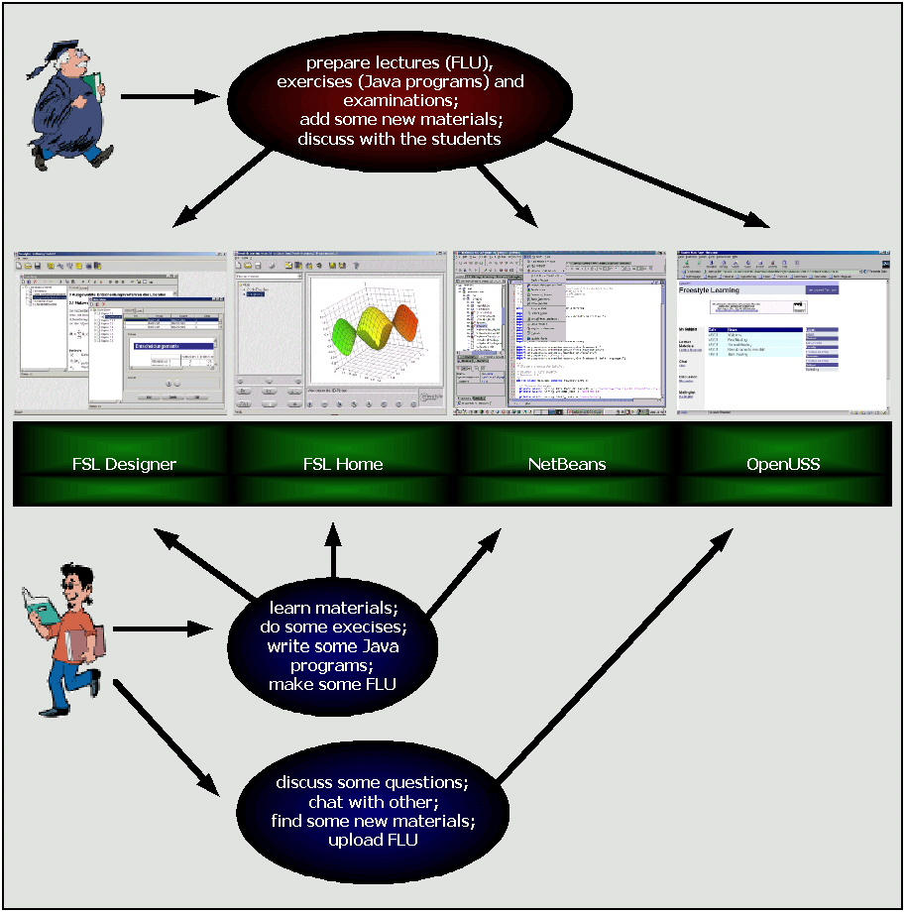
Fig. 2: Teaching and learning process Java with NetBeans, FSL and OpenUSS

All of the products used in this scenario are open source, so there is no need for the teachers and students to pay for software licences. This makes it much easier not for both the teachers and students to get up and running. There are also many other ways that CAT+CAL technology can be incorporated into the educational cycle, from courses offered exclusively online to posting supplemental material on a school website. The only limits are the bounds of your imagination!

What's more, advanced students can immediately put their Java skills to use by helping to develop NetBeans, FSL and OpenUSS. Participation in open source projects also gives students valuable real-world experience with large-scale programming projects.

Open Source and Java for Education?
As Java becomes more widespread, more and more programmers are jumping on the Java train. The very fact that Java is now the most popular programming language is one of the main reasons why educational software should also be written in Java. Software written in Java further supports the open source movement by allowing users the choice of using Linux as well as Windows without limiting its audience by writing Linux-only software.

This article shows the power of open source software in the educational area. Using NetBeans, FSL and OpenUSS for a Java course is only one example of the many possibilities out there. What we have to do now is help support open source software development and integration in order to keep open source on the cutting edge. You don't have to begin with your own open source project, just choose one that is a good fit for you and join that project! For those interested in the use of Java in the educational area, NetBeans, FSL and OpenUSS are a great place to start. The success of open source educational software can bring equality of knowledge to the internet. The one question left is: do you want to do it?

Acknowledgements
I would like to thank George Dvorak for commenting, editing and giving me a chance to publish this article. Further, I would like to acknowledge Prof. Dr. H. L. Grob for providing me his CAL+CAT papers.

Contacts and Project's Status

NetBeans
NetBeans (http://www.netbeans.org) is an open source, modular IDE, written in the Java programming language. Currently it supports Java development, but its architecture lends itself to supporting other languages as well. NetBeans is also an extensible tools platform into which other tools and functionality can be seamlessly integrated by writing and incorporating modules. The NetBeans core can be used as a generic application framework to simplify writing non-IDE applications. Since it's written in the Java language, it'll run on any platform with a virtual machine.

George Dvorak (george.dvorak@sun.com)

Freestyle Learning and OpenUSS
OpenUSS (http://openuss.sourceforge.net) is build as an open source project since the beginning. FSL (http://www.wi.uni-muenster.de/aw/freestyle-learning/english/eindex.htm) is a mature product and already established within the University of Muenster. This project is now declared as an open source project. Within a few weeks this project will be released under GPL at SourceForge.

Prof. Dr. Heinz Lothar Grob (grob@wi.uni-muenster.de)
Dr. Frank Bensberg (awfrbe@wi.uni-muenster.de)
Jan vom Brocke (awjavb@wi.uni-muenster.de)
Norman Lahme (lahme@wi.uni-muenster.de)
Blasius Lofi Dewanto (dewanto@uni-muenster.de)

References
[1] Stewart, B. (2001): Java as a Teaching Language, at http://java.oreilly.com/news/teachjava_0101.html
[2] The concept of CAL+CAT (all papers are in German language) can be found at: http://www.wi.uni-muenster.de/aw/abcalcat.htm
[3] Pdf documents about Freestyle Learning and OpenUSS.

