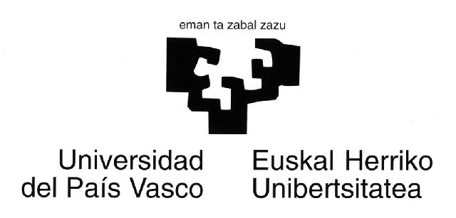

@LIS Call for proposals
e-learning and cultural diversity pilot project named

“SKILL SHORTAGE”

LETTER OF COMMITMENT
for taking part at the project “SKILL SHORTAGE”

The University of the Basque Country (UBC) is the main and biggest university in the Basque Country. It has 55.000 students and 4000 Faculty members and has a whole presence in every land of the Basque Country. In 1997 the UBC created a Virtual Campus and developed a complete system for Video Conference based in ATM communications. As a result of its experience in this issue the Virtual Campus of the UBC is interested in carrying out projects with others transnational institutions and partners in order to increase the knowledge about e-learning and the multivariable processes that it involves. The Virtual Campus of the UBC is deeply interested in innovation actions and in the creation of powerful nets of knowledge among different partners which are working in the same field. Nowadays the Virtual campus of UBC is a partner of Basque Government for The Develop of Society of Information and Knowledge.

As the main goal of the project is to develop in networking e-learning (NET-LEARNING) in a context of cultural diversity among Europe and Latin American countries, we do believe there is a high communality between our goals and experience and the aim of the project. It has called our attention the “Developmental Skill International Virtual Advanced Laboratory”, because it focus in one oh the main axis and problematic area in order to develop e-learning: Virtual Laboratories are one of more important components of e-learning and they have had a poor develop until now. In other way skills for working in Virtual Laboratory and in e-learning focus in the competencies that people will need when using these tools in innovative ways. So we do believe that the participation in this project will be a important opportunity for share experiences, doubts and the search of some answers, with an important and diverse community of researchers and professionals; so we expect the project will provide for a collaborative work ambiance, new and innovative experiences and a net for future works.

In particular, and according with our background and interest we propose to contribute to the project

- Cooperating with the partner net in the research about what kinds of knowledge models are, which are their characteristics, which are prevalents and the reasons why they are…and any other question related with the research about knowledge models.
- Collaborating with the partner net in research about the attitudes of Faculty and students to ICT in general and e.learning in particular. How do they work in e learning scenario?, Which of their behaviours are really innovative, how do they organise their knowledge in the new scenario?… These and others similar are questions related with the use of new e-learning tools about we have many questions and no answers.
- Studying the role of the contents in e.learning and the way to improve and create them.
- Participating in pilot projects or experiences.
- Collaborating in the research about the skills for manage knowledge in e-learning scenario.
- Making surveys and field studies between our students and faculties; even in our society.
- Developing and experiencing with new materials an new contents
- Disseminating the progress and results between basque society

According with it we declare our interest, agreement and commitment with the project, and the intention of collaborate to reach the goals and also in the actions of disseminations of the outputs..

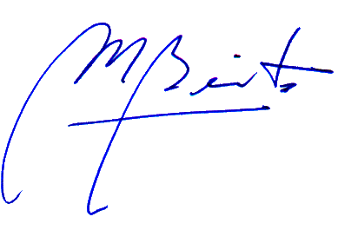
Name : Manuel Benito Gómez
Position : Vice Director of Virtual Campus
Place and date ; Leioa , June 28 2002

